CDC

**2023**

**Notes on Module 1 and 2**

All the Best for the sessional!

Module 1: Holistic Well Being

What is Holistic Well Being?

Holistic Wellbeing is how we respond to life’s ups and downs that includes how a person thinks, handles emotion and responds in his/her daily life.

Mental Wellbeing is the route to attain holistic health.

Mental wellbeing includes our emotional, psychological, and social wellbeing. It affects how we think, feel, and act. It also helps determine how we handle stress, relate to others, and make healthy choices.

Mental health is important at every stage of life, from childhood and adolescence through adulthood.

Holistic effect of Happiness on our bodies….

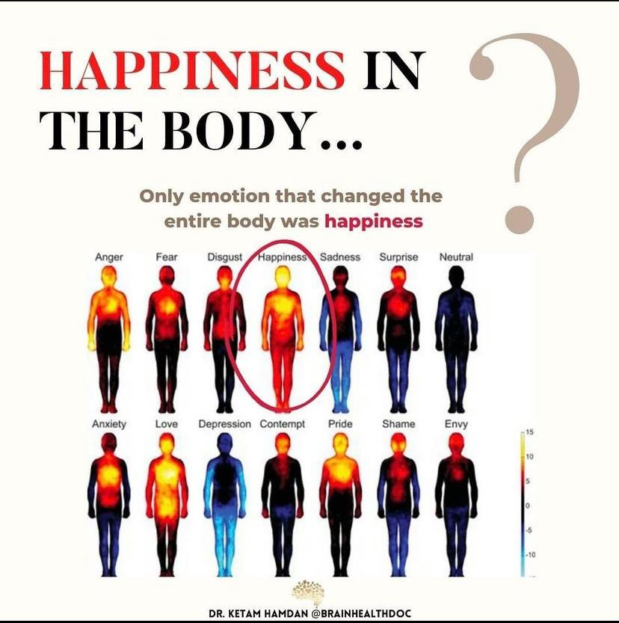

Happiness has real physical changes in the body.

Being elated lowers the levels of the stress hormone **cortisol.** This increases the production of **endorphins** and **serotonin**, which is also known as the happiness hormones.

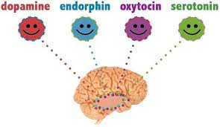

Defining Dopamine:

Dopamine is a chemical produced by our brains that plays a starring role in motivating behavior. It gets released when we take a bite of delicious food, when we have sex, after we exercise, and, importantly, when we have **successful social interactions**.

Typical Escape Loop of Engagement

* We become bored, anxious, unhappy or lonely – feelings from something unfulfilled in your life,
* These feelings bring with it a low-level stress and our cortisol levels start to rise
* We feel the urge to resolve this and are faced with a choice: Solve the root cause (which is difficult) or seeking an “escape” which is cheap and easy to attain and gives us the highest spike of dopamine,
* Feeling that hit of pleasure for this escapism, we start to rely on it, creating a dependent feedback loop.

The attention Economy:

Social media apps are free to us because we are the product being sold.

Each app is caught in a race for your attention, competing not just against other apps, but also against your friends, your family, your hobbies, and even your sleep.

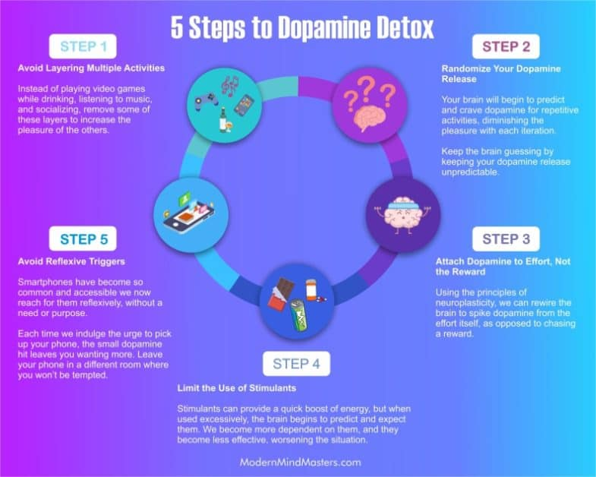

Wheel of Wellbeing (wow)

The World Health Organization defines health as a *“state of complete physical, mental and social wellbeing.”*

**Happiness** is an emotional state characterized by feelings of joy, satisfaction, contentment, and fulfillment.

While happiness has many different definitions, it is often described as **Contentment** involving positive emotions and life satisfaction.

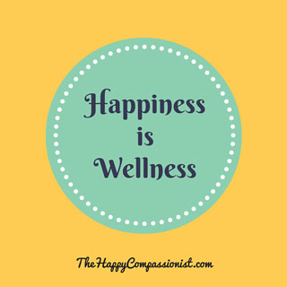

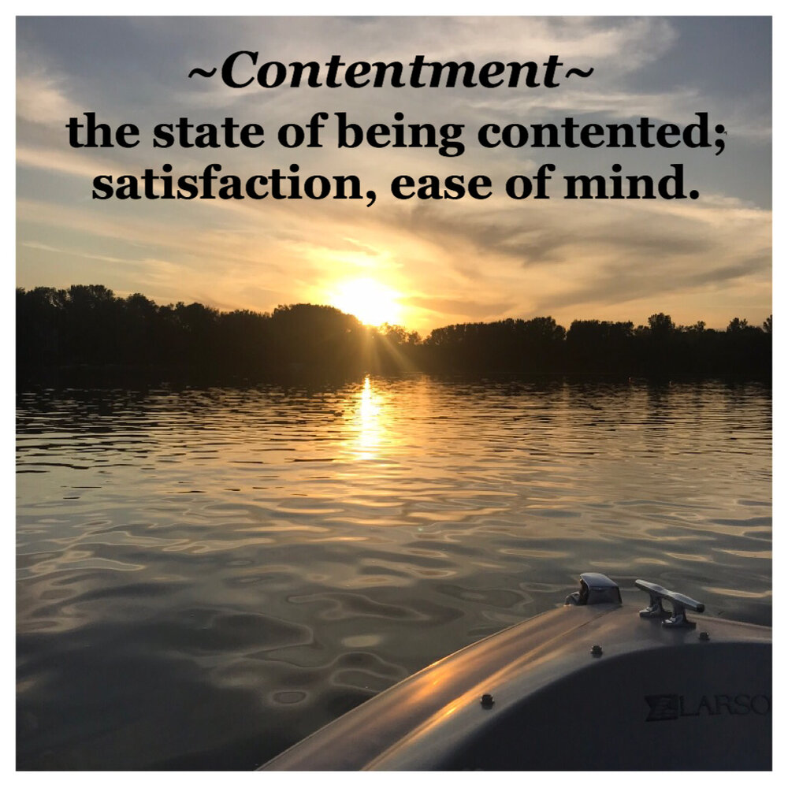

Factors Determines Happiness:

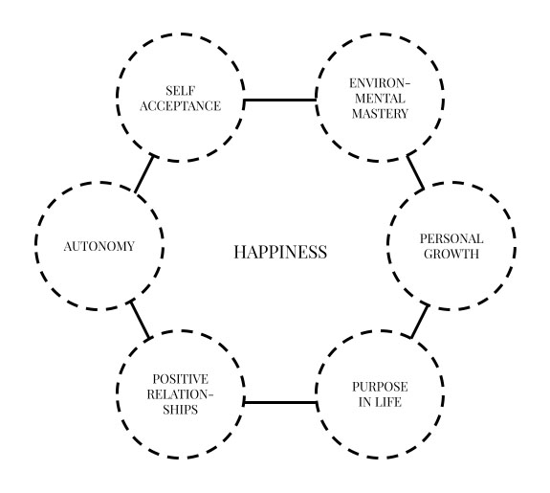

PERMA: To nourish your wellbeing

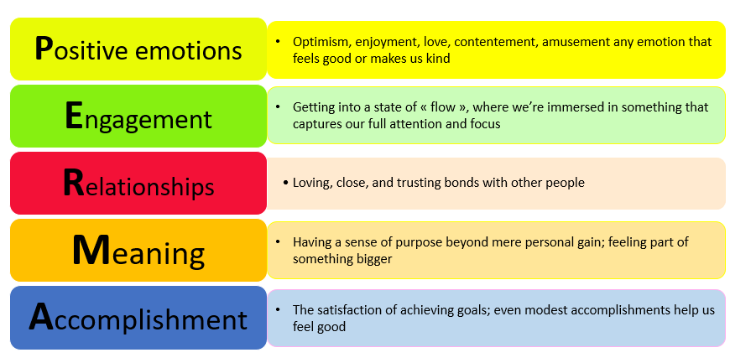

Module 2: Leadership Skills

Defining a Leader: A leader is someone who envisions a goal and empowers his/her team to achieve it. A leader’s action inspires others to:

To dream more

To learn more

To do more

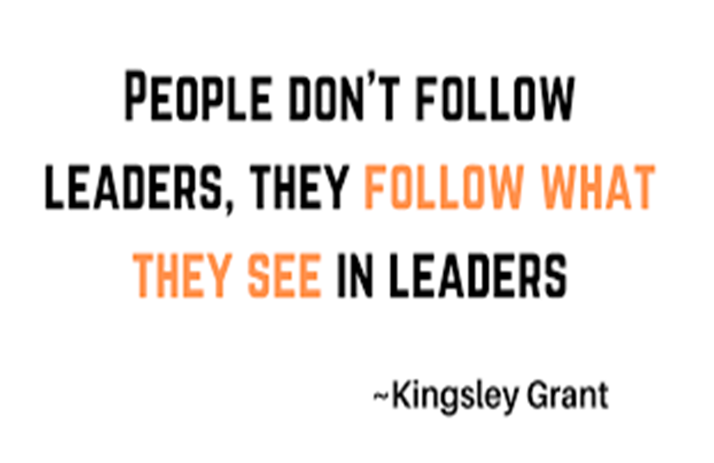

**Qualities defining a Leader:**

Self-Awareness Integrity Ability to Delegate

Communication Gratitude Empathy

Courage Respect for self and others

Accountability Focused Creativity and Enthusiasm

Problem Solving Team Dynamics Conflict Handling

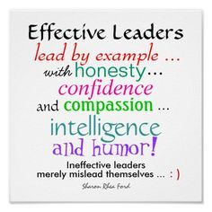

Leadership is positively influencing people to follow:

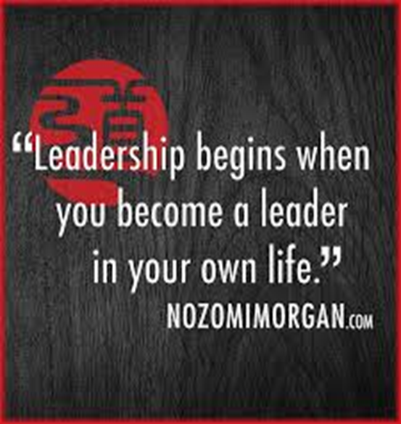

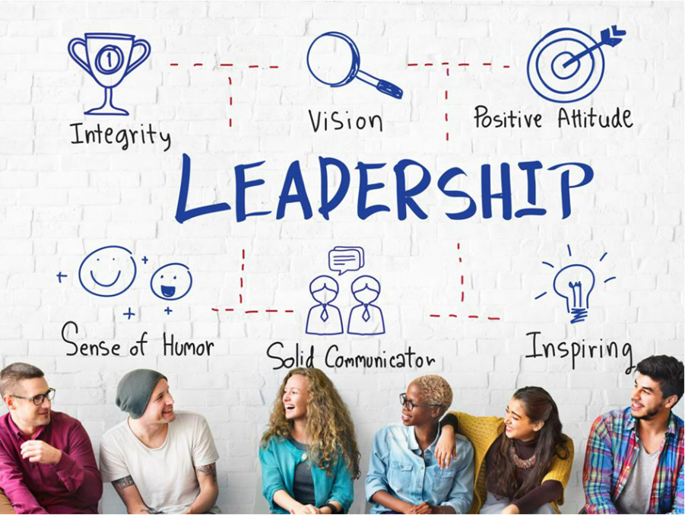

John Adair’s Action Centered Leadership Theory:

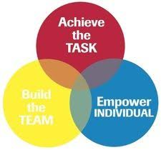

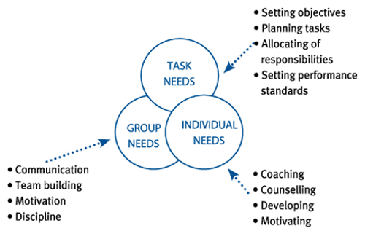

It all starts with you = Team = Growth

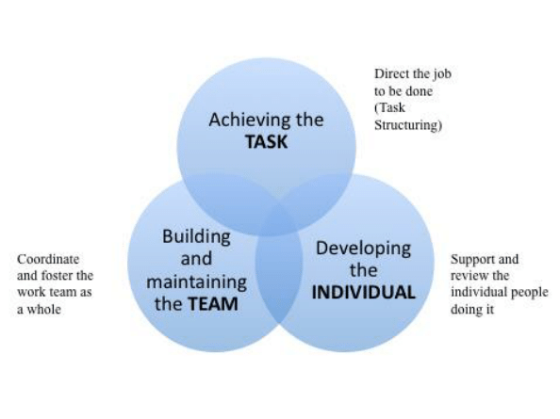

Ethics and Values:

Values:

**Values** are individual beliefs that motivate people to act one way or another. Our values inform our thoughts, words, and actions.

Some of the examples of values:

Loyalty Humility Compassion

Honesty Kindness Integrity

Selflessness

**Ethics:**

Derived from Greek word, ethos which means custom, habit, character or disposition.

Ethics guides us to tell the truth, keep our promises, or help someone in need.

Ethics help us to take the right decisions that create positive impact.



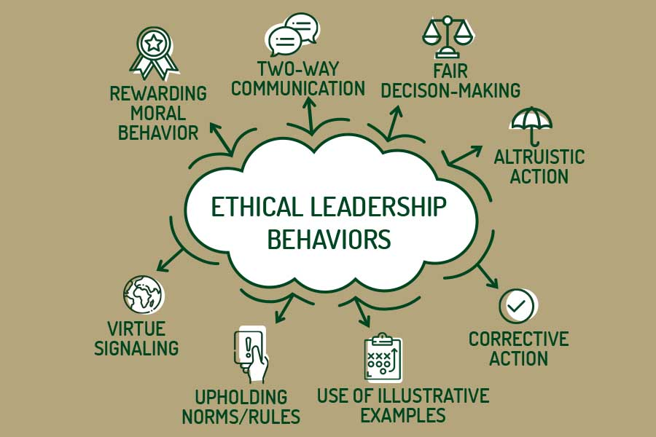

Integrity:

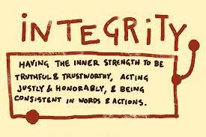

Honesty = Integrity



Integrity Spotlight:

